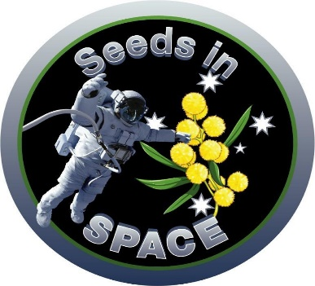
Nov 7th, 2020
For Immediate Release

What’ll Happen to the Wattle??!

SYDNEY --One Giant Leap Australia Foundation is sending native golden wattle seeds to the International Space Station in early December, 2020.

In collaboration with the Japan Aerospace Exploration Agency (JAXA) the seeds will live in space for six months, returning to Australia in time for Science Week 2021.

Supported by the Australian Space Agency, the "What’ll happen with the wattle??!" programme is being offered to more than 150 schools, scout groups and Australian Air Force Cadets across Australia.

A community panel judged the applications that included 200 words and a short video, explaining what the schools would do with the wattle once it had grown.

One of the panel members said, “We have spent 5 days watching videos. Entries from all over Australia. From a single teacher in a face mask in a school in Victoria to a small school in remote Northern Territory. It has been an amazing opportunity to laugh and cry our way through them.”

Once selected, the chosen schools around Australia will receive wattle seeds that have flown to space, plus seeds that have not. The seeds are from the same seed lot. Students are asked to
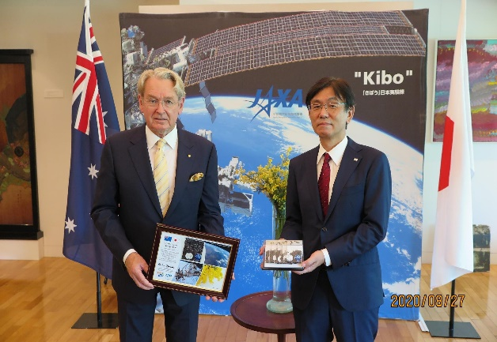
germinate and grow their seeds, recording data about the germination and seed growth. Data will be uploaded to the ‘What’ll happen to the wattle??!’ app.

Throughout the programme, One Giant Leap Australia Foundation will run teleconferences and provide educational support to participating groups.

The 12-month to 2 year project will result in the creation of a nationwide map identifying the location of Australia‘s 'space wattle’ trees.

The project is an historic opportunity for Australian schools and students. Japanese Aerospace Exploration Agency (JAXA) media announcement:
Principal: Ms Gayle Cope
Wattle Park Primary School
Burwood
Victoria
(03)9808 2165
https://iss.jaxa.jp/en/kuoa/news/200901.html

For further information, please contact:
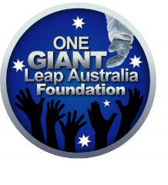
Jackie Carpenter
Director
One Giant Leap Australia Foundation
041 232 6509

